# .PCD v.7 - Point Cloud Data file format

VERSION .7

FIELDS x y z rgb

SIZE 4 4 4 4

TYPE F F F F

COUNT 1 1 1 1

WIDTH 213

HEIGHT 1

VIEWPOINT 0 0 0 1 0 0 0

POINTS 213

DATA ascii

0.93773 0.33763 0 4.2108e+06

0.90805 0.35641 0 4.2108e+06

0.81915 0.32 0 4.2108e+06

0.97192 0.278 0 4.2108e+06

0.944 0.29474 0 4.2108e+06

0.98111 0.24247 0 4.2108e+06

0.93655 0.26143 0 4.2108e+06

0.91631 0.27442 0 4.2108e+06

0.81921 0.29315 0 4.2108e+06

0.90701 0.24109 0 4.2108e+06

0.83239 0.23398 0 4.2108e+06

0.99185 0.2116 0 4.2108e+06

0.89264 0.21174 0 4.2108e+06

0.85082 0.21212 0 4.2108e+06

0.81044 0.32222 0 4.2108e+06

0.74459 0.32192 0 4.2108e+06

0.69927 0.32278 0 4.2108e+06

0.8102 0.29315 0 4.2108e+06

0.75504 0.29765 0 4.2108e+06

0.8102 0.24399 0 4.2108e+06

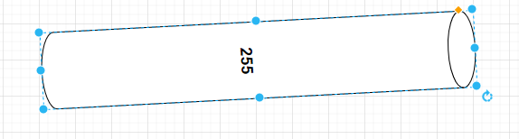

Data reading from sonar is (0-255)

Example: 3 7 4 4 4 0 0 0 0 0 0 0 100 110 125 185 255 255 255 255 255 10 200